Decentralized Energy Markets: Peer-to-Peer Energy Trading on Blockchain.
Ibrahim Mohamed
Department of Information Technology
International Burch University
Sarajevo, Bosnia and Herzegovina
Ibrahim.mohamed@stu.ibu.edu.ba

ABSTRACT
The growing demand for sustainable, reliable, and consumer-oriented energy systems has revealed the fragility of existing centralized energy systems. This study investigates the growth of decentralized energy markets enabled by blockchain technology, emphasizing peer-to-peer (P2P) energy trading systems. It explores how blockchain enhances transactional transparency, automation, and trustless interactions among prosumers, often leveraging IoT devices and renewable energy sources. The research paper describes a layered architecture for P2P trading platforms utilizing smart meters, smart contracts, and market interfaces. The research paper describes how yet with advances in technology that include blockchain technology, and the development of IoT devices, there are remaining impediments to large-scale deployment including scalability limitations, interoperability, regulations, data privacy issues, and expensive infrastructure costs. These barriers need to be addressed to support successful large scale deployment. This research indicates that blockchain technology has the potential to change the energy sector with the correct policies, innovations, and incentives in place that place the consumer or end user at the forefront.
Keywords: centralization; decentralization; Peer-to-Peer Energy Trading; Microgrid; Internet of Things (IoT) in Energy; Distributed Ledger Technology (DLT); Blockchain; Smart Contract; single point of failure; security.

Introduction
Traditional power systems, with large scale central plants and one-way electricity flow, are certainly not able to meet the needs of an ever-increasing demand for energy from our modern society [1]. Many, if not all, traditional systems have old and decaying infrastructure that is being challenged by distributed renewables, changing consumption patterns, and poor pathways for participation in the market. Regular increasing transmission losses, regulatory burdens and lack of integration of the prosumer indicate that we need to address how we may change the way we are to provide our energy service.

The way we consume energy has altered with the evolution of electric vehicles, battery storage and distributed solar. Presently, consumers have begun to generate more electricity in times of peak generation than they consume, and consume more energy in times of peak demand at night. However, current structures for electricity market participation do not facilitate direct transactions among remote participants, nor create economic opportunities for individual prosumers to be rewarded- forcing reliance on utility intermediaries. Secure and automated transactions can be established using blockchain platforms.

This study examines the possibilities of peer-to-peer (P2P) energy trading systems based on blockchain technology, examining their features, advantages, and the various obstacles that stand in their way.

Energy Systems
Since global energy demand increases and sustainability becomes a main concept, the limitation of centralized energy systems are increasingly apparent. As a solution, decentralized energy systems have arisen as a viable alternative. This section provides an overview of both models and compares its main characteristics in terms of infrastructure, consumer roles, efficiency, and market dynamics.

Traditional Centralized Energy Markets
Conventional energy markets function using grid systems where one or several facilities determine, transmit, and distribute energy. These grids rely on powerful power plants that are almost always far from where the energy is consumed (in many cases, many miles), requiring extensive infrastructure. The plants are powered by fossil fuels, which are not a sustainable option [2]. Centralized pricing and energy management limits consumer engagement, along with local energy options and could lead to monopolistic activity [3].

Decentralized Energy Systems
Decentralization Energy resources Systems (DERS), including solar panels, wind turbines and a small scale storage, provided an alternative model. Microgrids - local energy networks - power generation and consumption within the confined areas, reduces transportation, enhancing flexibility, and increase environmentally friendly energy [4]. DERS enables consumers to become "prosumers" that can produce and consume energy and limit the possibility of monopoly [3].

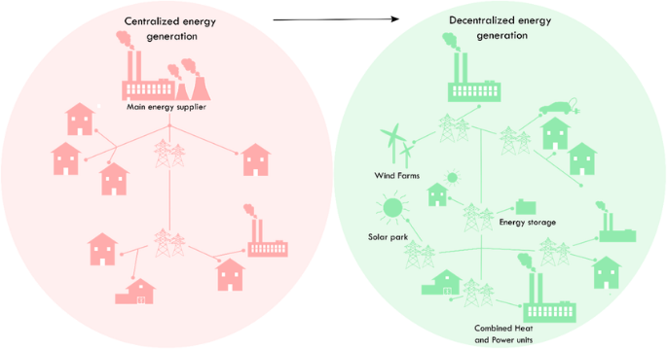
Figure 1: Centralized and decentralized energy system

Blockchain Technology in Energy Trading
Blockchain technology introduces a decentralized, transparent, and secure framework for energy trading, enabling efficient peer-to-peer (P2P) transactions without relying on centralized intermediaries.

Decentralization and Disintermediation
Traditional energy markets are highly dependent on the central authorities for the production, distribution and bills management. Blockchain eliminates the need for brokers by allowing professionals to deal directly. This transformation enables users, reduces the costs of transactions, and leads to access to the energy market.

Transparency and Trust
Each registered transaction on Blockchain is a chronological and non-changing seal. This ensures that all participants have a simultaneous and effective record to check energy exchange, which enhances confidence and reduces the risk of fraud or manipulation.

Smart Contracts and Automation
Smart contracts are the code of self-executing guaranteed in Blockchain that imposes trading rules automatically. It provides automatic bills, dynamic pricing, energy participation agreements, and settlement operations without supervision of the third party.

Security and Resilience
Blockchain networks are safe due to their foundations for encryption and distributed architecture. Repeating data through multiple contract makes the system resistant to electronic attacks and single failure points, which enhances grid resilience [5].

Integration with Renewable Energy and IoT
Blockchain facilitates the seamless integration of distributed renewable energy sources and IoT devices. Smart meters can autonomously record energy production/consumption and trigger blockchain transactions, enabling real-time, data-driven trading decisions.

Architecture of a P2P Energy Trading System
Decentralized energy trading via a blockchain-based peer-to-peer energy trading system provides a mechanism for decentralized energy transactions between producers and consumers (prosumers) without relying completely on traditional utility to distribute and facilitate those transactions. This system will rely on multiple layers of technology and infrastructure to allow for secure, efficient, and automated energy trading. These components are described below.

Prosumers and Smart Meters
At the edge of the system we have prosumers that use solar panels or other sources to produce and consume electricity (e.g., storage units). These prosumers have a smart meter that measures their direct energy production and consumption in real-time [6]. Smart meters or other energy data collection devices are valuable as they allow for immediate energy data and blockchain transactions.
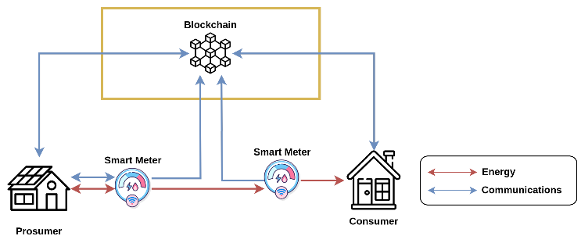
Figure 2: Simplified diagram for interactions among prosumers, consumers, IoT devices, and the blockchain network.

Blockchain Layer
This layer acts as a distributed ledger storing all transactions in a secure environment in a transparent and immutable manner [7]. Each energy transaction becomes a transaction in the blockchain that is secure from external and internal attack, and more importantly, traceable and responsible. The blockchain representing the network can operate as a public, private, or consortium model depending on regulatory requirements or scalability by design.

Smart Contract Layer
Smart contracts based on distributed ledger technology can automatically enforce agreements for trading energy. The features that are typically automated are keeping the energy price and standards for matching demand with supply, validating transactions and payment settlement. For instance, if a consumer agrees to purchase 5 kilowatt-hours of energy for a specific price, the smart contract will auto-verify the transaction process and automate the payments once the power is connected.
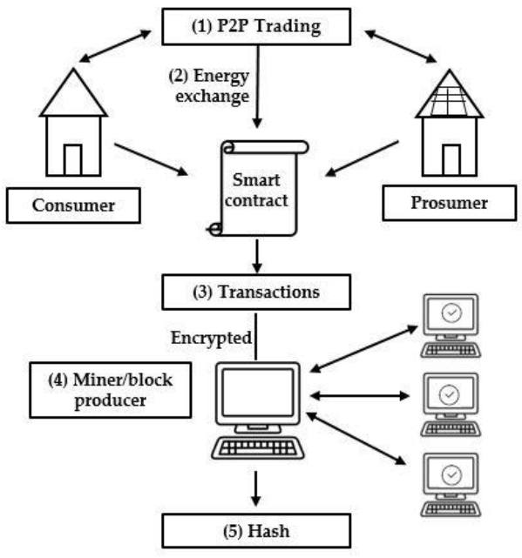
Figure 3: Blockchain-based P2P Energy Trading Framework

Challenges and Limitations of Blockchain-Based P2P Energy Trading

Scalability and Energy Consumption
Blockchain networks are currently facing challenges in their ability to be scaled to handle the rapid rate of small transactions typical of P2P energy markets. Traditional Proof-of-Work (PoW) systems operate slow and require a lot of energy resource operations, meaning they are not aligned with the goals of sustainability [8]. Proof of stake (PoS) and alternative consensus approaches such as PBFT and DAGs promote speed and energy efficiency but sacrifice a few other variables when it comes to our requirements around security and decentralization. Permissioned blockchains are faster and more private approaches but do not allow for as much openness. The obstacle for the blockchain-based energy trading community is to find a way to balance scalability, security, decentralization, and energy-efficiency across all fronts so as to optimize all facets of the consensus we choose to adopt.

Interoperability and Standardization
A functioning P2P energy system will require data to be exchanged seamlessly across smart meters, IoT sensors, distributed energy resources, and various blockchain platforms. Currently, smart grid components don't speak the same language, using various communication standards, while blockchain technologies are spread from Ethereum to Hyperledger and IOTA. Without common data models or middleware to enable seamless integration, we are reliant on custom-designed bridges for integration, which incurs high costs and complexity. Interoperable frameworks, reference architectures, and common smart contract models are being developed under the auspices of industry and consortia. But until visually accepted open APIs or standards for data formats are established, many pilots will remain siloed.

Regulatory and Legal Barriers
Energy markets are highly regulated and differ substantially from region to region. In some areas of the European Union, directives allow for a peer-to-peer energy trading mechanism amongst energy communities through automated contracts. In many other areas, monopoly or single-buyer models do not permit decentralized sales and require blockchain disruptors to comply with archaic rules for grid acc

Data Privacy and Security
Transparency on the blockchain may conflict with consumer privacy. On-chain transactions - such as timestamps, transaction volumes, and volume of pseudonymous addresses - can be aggregated to individuals usage patterns which could reveal one's household behavior. Privacy-preserving techniques (zero-knowledge proofs, ring signatures, and off-chain channels) can aggregate sensitive details, but related privacy-preserving techniques tend to be computationally expensive and complex. Additionally, the immutable nature of blockchain technology means that the aspects of data cannot be pulled back; data can be written as being correct or incorrect or disclosed without authorization, but once the data is recorded, the data cannot be pulled back because the transaction has taken place. Organizations must appropriately secure their endpoints (i.e., the smart meter or Internet of Things (IoT) devices) from tampering, but security will continue to be a critical factor in these disruptions. It is still immensely complicated to maintain and accomplish transparency (which provides trust) and consumer privacy (providing confidentiality).

User Adoption and Digital Literacy
Technical feasibility might not be able to ensure social adoption. A large number of potential users are not acquainted with blockchain technology, digital wallets or smart contracts and user interfaces must be as intuitive as possible. Low digital literacy and limited internet access – often in rural or underserved communities – may also deter participation. Users are responsible for managing encryption keys or they may lose access to their money and energy credits, and while concerns about fraud or a failure of the system may also deter user participation. Overcoming these hurdles will require easy-to-use applications, educational programs, and potential intermediaries (like local cooperatives) to help less-educated participants in implementing the technology.

Conclusion
The power of peer-to-peer (P2P) energy trading using blockchain technology marks great strides toward energy systems that are democratic, robust, and sustainable. Blockchain represents a route in which existing energy systems can support decentralized energy systems with consumer-focused real-time markets as they are democratizing, removing intermediaries, automating transactions, and offering more transparency for communities when interacting with energy systems.

Nevertheless, we still have a long way to go. We must understand and address the technical limitations surrounding blockchain (scalability and interoperability) and also the social, technical, regulatory, and financial barriers that remain for communities in order to unlock this model to its fullest potential. Some of solutions include: advanced consensus protocols which effectively allow P2P energy trading, interoperable platforms, regulatory reform, and user-centered design in order to be accessible to more populations and not concentrate usage to more privileged urban communities.

As research and pilots continue to develop to better understand what 'decentralized energy systems' can potentially mean, it is never too soon to start bringing technologists, policymakers, and communities together to promote trust, establish standards, and share opportunities in using blockchain technology power decentralized energy markets.

References

- A. Ghafoor and S. K. Khan, "Limitations, challenges and solution approaches in grid-connected renewable energy systems," International Journal of Renewable Energy Research, vol. 9, no. 1, pp. 244–251, 2020.
- M. R. AlRashidi and K. M. EL-Naggar, "Economical operation of modern power grids incorporating uncertainties of renewable energy sources and load demand using the adaptive fitness," Electric Power Systems Research, vol. 148, pp. 109–120, 2017.IEA, Power Systems in Transition: Challenges and opportunities ahead for electricity security, International Energy Agency, 2021.
- A. Pandey, A. Pandey, and J. R. Saini, "Decentralized Energy Markets: Enhancing Peer-to-Peer Energy Sharing with Blockchain," in Proc. 2024 International Conference, pp. 874–881, Sep. 18, 2024.
- N. N. Omar and M. A. Saleh, "Power to the People: Advancing Resilient and Sustainable Decentralized Energy Distribution Systems," presented at the 13th London International Conference, London, U.K., Jul. 24–26, 2024.
- D. Huang, S. Ma, D. Zhou, C. Zhang, H. Han, Q. Li, T. Li, and C. Wang, "A Framework for Decentralized Energy Trading Based on Blockchain Technology," Applied Sciences, vol. 12, no. 17, pp. 8410–8410, Aug. 2022.
- P. Wongthongtham, D. Marrable, B. Abu-Salih, X. Liu, and G. Morrison, "Blockchain-enabled Peer-to-Peer Energy Trading," Computers and Electrical Engineering, vol. 94, 2021, Art. no. 107299.
- K. A. Shastry, S. Kiruthika, and K. Kumar D, "Blockchain technology: A new era of transaction processing – decentralized, secure ledger transforming global transaction processes," Indian Scientific Journal of Research, vol. 8, no. 10, pp. 1–8, Oct. 16, 2024, Indospace Publications.
- N. Wang, X. Zhou, X. Lu, Z. Guan, L. Wu, X. Du, and M. Guizani, "When energy trading meets blockchain in electrical power system: The state of the art," Applied Sciences, vol. 9, no. 8, p. 1561, Apr. 15, 2019, MDPI AG.

